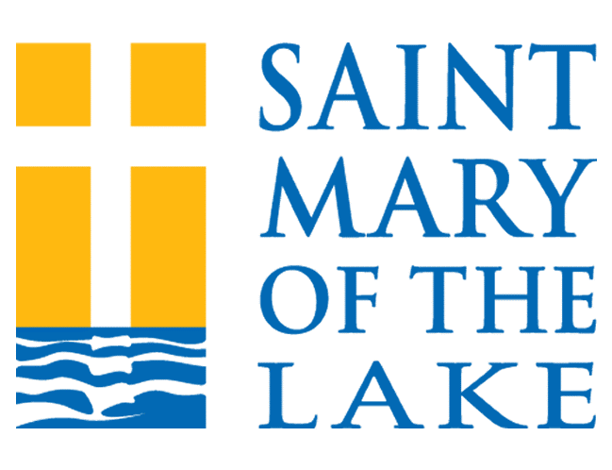
2024/2025 Sacrament Preparation Registration Form

Date: Click or tap to enter a date.
PARENT INFORMATION
Parents/Guardian Full Legal Names: Click or tap here to enter text.
Full Address: Click or tap here to enter text.
Primary Phone: Click or tap here to enter text. Cell Phone: Click or tap here to enter text.
Email(s): Click or tap here to enter text.
St. Mary’s Parishioner: Yes ☐ No ☐
Non-Parishioners: There are a limited number of spaces available for Confirmation. A newly issued baptism certificate, a letter of consent from you Pastor, and the fee are due with registration.

YOUTH INFORMATION
Legal Full Name (First, Middle, Last): Click or tap here to enter text. Male ☐ Female ☐
Grade in 9/2024: Click or tap here to enter text. Age on 4/1/2025: Click or tap here to enter text.
Check all that apply: ☐ Confirmation ($40/$50 non-Parishioners) – ☐ 4:30 PM
Registration deadline is 9/16/2024. No younger than 8th grade.
☐ Eucharist and Penance & Reconciliation ($40) - ☐ 4:30 PM ☐ 6:15 PM
Registration deadline is 11/11/2024. No younger than 2nd grade.
Place of Faith Formation:
2024/2025: St. Mary’s ☐ Frassati ☐ Name of other parish or Catholic School: Click or tap here to enter text.
2023/2024: St. Mary’s ☐ Frassati ☐ Name of other parish or Catholic School: Click or tap here to enter text.

Proof of baptism is required for all Sacrament Preparation
- Please provide a newly issued baptism certificate for your child. Contact parish where the Baptism took place.
- If Baptized at St. Mary’s provide date: Click or tap to enter a date.
- If your child is not baptized, or was not baptized in a Catholic church, please notify us right away.
- If you are not a St. Mary’s parishioner, you will need a letter of permission from your pastor.

Please Note:
See the Parish website after September 1, 2024, for an updated calendar of meeting dates.
There will be a $20 late fee charged for registrations received after the posted deadline.

OFFICE USE ONLY:
AMT PAID $ Check # Cash or Credit Card DATE

